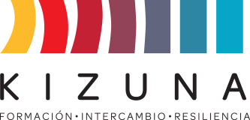

**ANNEX II**

**ACTION PLAN PROPOSAL**

An expected outcome of the International Course "Training Program in Soil Geology for Non-Specialist Engineers" is the formulation and presentation by each participant of an Action Plan. This is an action related to the application of the acquired knowledge that can be implemented in the country of origin. This action plan will be presented to the governing bodies and will promote or assume its execution upon completion of the training program.

The Course organizers, AGCID and the University of Chile, may subsequently monitor the development of the Action Plans. The aforementioned action plan will be proposed as an initial idea and must be submitted as an application requirement. Subsequently, during the International Course, the instructions, procedures, and basic scientific knowledge required to complete the plan will be provided. As part of the Course evaluation, the plan must be presented to the academics organizing the Course, receiving feedback and final suggestions.

**INSTRUCTIONS**

*Develop the following points in a Word or PDF document of no more than 5 pages, including text and tables.*

1. Name of participant.
2. City and country of residence.
3. Institution of employment and position held.
4. Indicate the aspects of the course that you found the most relevant.
5. Specify how the knowledge acquired in this International Course will enhance your professional development in your country and what concrete actions you hope to take to achieve this.

|  |  |  |  |
| --- | --- | --- | --- |
| **OBJECTIVE** | **ACTIVITY** | **OUTCOME** | **TIME** |
|  |  |  |  |
|  |  |  |  |
|  |  |  |  |
|  |  |  |  |

1. Comments and suggestions.