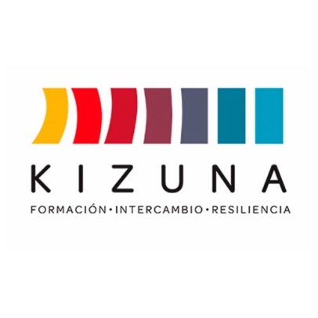

ANNEX V
LETTER OF INSTITUTIONAL COMMITMENT
(to be signed by the applicant’s direct supervisor)

I, the undersigned, on behalf of ________________________________________ (Applicant's institution of employment), hereby commit to supporting _________________________________________ (Name of applicant) in developing the initial idea for the proposed Action Plan (Annex II of this Call for Applications) in the event they are selected to participate in the “International Course, 2nd Edition: Threat assessment due to flooding and mass removal in uncontrolled basins and with little information”. The institution also commits to the following after their completion of the training course:
- Encouraging the selected participant to deliver the Action Plan to our institution upon completing the course.
- Guiding the Action Plan proposed by the selected participant after completing the training program, according to the interests, needs, and possibilities of our institution and the country.
- Promoting the development of the Action Plan as part of the selected participant’s work responsibilities, unless contingencies at our own institution prevent it.
- Ensuring the information regarding the progress, achievements, or setbacks in implementing the Action Plan, as required by the Universidad de Chile, AGCID, or the Kizuna coordination team, is communicated effectively.

In _____________________________ (city, country), on this date of _______________.
SIGNATURE: _____________________________________________
NAME:
POSITION: E-MAIL:
** PLEASE INCLUDE THE STAMP OF THE INSTITUTION**

Failure to implement the Action Plan will not result in any negative consequences for the participant or their institution of employment. However, it is strongly advised that the Universidad de Chile be informed of the reasons it failed to be implemented.

