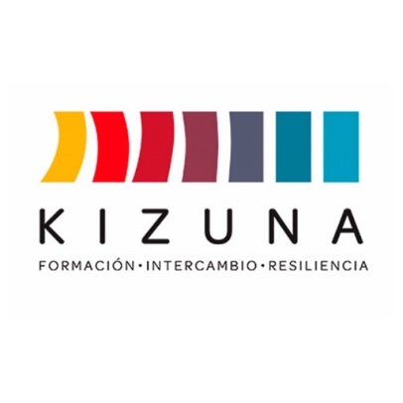

ANNEX II
APPLICANT’S LETTER OF INTENT
Building Resilient and Sustainable Societies Against Disasters in Latin America and the Caribbean Project (Kizuna II).

As an applicant to the International Course, 2nd Edition: “Wildfire Protection”, which will taught by the Corporación Nacional Forestal (CONAF) between September and December 2025:

I, _______________________________________________________________

Name of applicant
FROM____________________________________________________________

Country of origin

Declare that all the information provided is true, correct and complete, and if awarded the scholarship, I agree to the following rules and conditions:
- I shall strictly comply with the course programme.

- Accept all conditions regarding the course.

- Respect all instructions given during the course.

- Adhere to the course timeframe established by the CONAF and AGCID.

- I shall neither suspend or interrupt my studies, except in the case of a serious illness that prevents me from continuing the training course.

- I declare there are no restraining orders or court cases against me that may prevent me from leaving the country or entering Chile.

- I shall have all of the necessary international documentation to enter and exit Chile, in accordance with the bilateral agreements between governments and valid for the entire duration of the course, including the travel dates established by the scholarship.

- Upon completion of the academic programme, I shall return to my country of origin, carry out knowledge transfer activities, and implement my final course project.

- Should I withdraw from the course after being selected, I agree to notify the AGCID Focal Point at least 10 days prior to the start of the course, indicating the reasons of force majeure that have required such a decision to be taken.

___________________ , __________ on the_______________, _______.
(City, Country) (Day) (Month) (Year)

_______________________________
Signature of applicant

