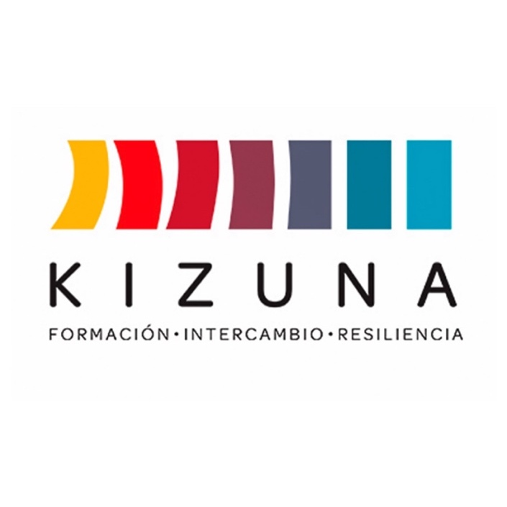

FELLOWSHIP CALL

INTERNATIONAL COURSE
“WILDFIRE PROTECTION”

2ND BLENDED LEARNING EDITION
From September 25 to December 3, 2025

Call for applications available at https://www.agcid.cl
Chilean International Cooperation Agency for Development (AGCID)

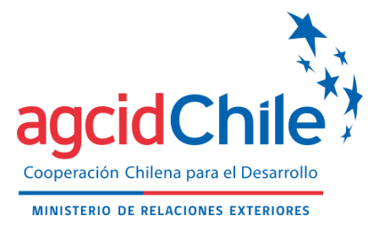 | 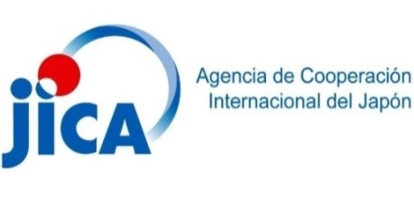 | 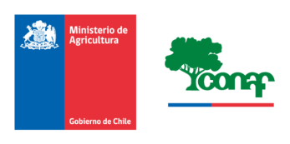
BACKGROUND
Latin America and the Caribbean is characterized as the second most disaster-prone region in the world (United Nations Office for the Coordination of Humanitarian Affairs, 2020). Disasters pose threats not only to human life and property but can also reverse development gains, erode resilience, and increase vulnerability.
In addition to natural phenomena that affect people and the environment, there are also forest fires, most of which are caused by humans, which also cause damage and require response actions.
That is why the Government of Chile, through its Chilean International Cooperation Agency for Development (AGCID), together with the Japan International Cooperation Agency (JICA), inspired by the 2030 Agenda and its sustainable development goals and the Sendai Framework for Disaster Risk Reduction, has promoted the creation of an alliance for the implementation of the Building Resilient and Sustainable Societies for Disasters in Latin America and the Caribbean Project (KIZUNA II), which is expected to contribute to the development and strengthening of the capacities of professionals and technicians in the region. The initiative is part of the second phase of the successful Kizuna Program, which trained more than 5,000 participants in Chile between 2015 and 2020.
The “Wildfire Protection” international course is expected to be a concrete international cooperation action that contributes to the development of professional, institutional, and public policy capacities to advance toward communities that are better prepared and more resilient to forest fires.
This initiative will be implemented for two (2) years starting in the Japanese fiscal year 2024 and consists of two (2) hybrid versions (one version in each Japanese fiscal year until 2025) as part of the KIZUNA II Project, which is under the umbrella of the Japan-Chile Partnership Program 2030 (JCPP2030) and the Technical Cooperation Agreement signed between the Government of Japan and the Government of the Republic of Chile.
The first edition of this international course was held in 2024, while the second version will be held this year, in 2025. The JICA, the AGCID and the National Forest Service (CONAF) are participating in its organization and development.

GENERAL INFORMATION
I. OVERALL OBJECTIVE
To promote policies, strategies, programs, and collaborative actions with countries in Latin America and the Caribbean (LAC) in accordance with the priorities for action of the Sendai Framework for Disaster Risk Reduction 2015–2030 and the Sustainable Development Goals (SDGs 2030).

II. OBJECTIVES OF THE COURSE
To present a comprehensive approach to wildfire protection management through the implementation of strategies and actions to prevent forest fires and mitigate their damage, prepare resources, response measures and actions, and organize forest firefighting operations, all with a view to preserving biodiversity, protecting natural resources and, above all, ensuring the safety of communities and forest ecosystems.

III. EXPECTED OUTCOMES
Course participants are expected to improve their knowledge and skills in:
- Understanding forest fire prevention and damage mitigation practices in the context of sustainable forest management.
- The ability to prepare and organize resources for forest firefighting as an integral part of environmental protection plans.
- The practical application of strategies and tactics for integrated forest firefighting.
- The strengthening of the ability to communicate knowledge and experiences, facilitating collaboration and the exchange of best practices in fire prevention and extinguishing.
- The development and implementation of an action plan, prepared by the attendee, aimed at wildfire protection and feasible to implement in their country. The subsequent implementation of this action plan is an important commitment of the participant (letter h, Annex II) and their sponsoring institution (Annex V) and will therefore be monitored by JICA, AGCID, and CONAF.

IV. IMPLEMENTING INSTITUTION
The implementing institution for this course will be CONAF, a private law organization under the Ministry of Agriculture whose main task is to administer Chile's forestry policy and promote the development of the sector.
The CONAF’s mission is to ensure the conservation, restoration, and sustainable management of the country's forest and xerophytic ecosystems through actions aimed at ecosystem management, monitoring, and afforestation in order to meet current and future demand for ecosystem goods and services. In doing so, it seeks to contribute to the territorial development, the development of indigenous peoples and vulnerable communities, and the appreciation of biodiversity in a scenario of climate change and sustainable development.

V. COURSE DURATION
This course will be taught from September 25 to December 3, 2025. It includes a first stage via streaming, with live transmission of classes taught by CONAF instructors through Meet, followed by a second stage in person in Chile.
The first stage, consisting of online classes, will be held between September 25 and November 12, 2025, in 21 sessions of approximately three hours, starting at 2:30 p.m. in Chile, at a rate of three sessions per week. The set of sessions includes a formal opening, 15 class sessions, two country presentation sessions, two evaluations, and a closing session. Due to time differences and seasonal time changes, the start of classes will vary between countries.
The second stage, in person, will take place from November 25 to December 3, 2025, with sessions in Santiago, Chile, and a tour of various regions of the country.

VI. LANGUAGE
The course will be conducted entirely in Spanish.

VII. BENEFITS OF THE FELLOWSHIP
Those selected will receive a fellowship covering 100% of the following items:
- Academic program enrollment and tuition fees.
- Certificate of completion.
- Round-trip airfare from the main international airport in the country of origin to Santiago de Chile (any stopovers within the country of origin must be paid for by the participant).
- Transportation in Chile from the airport to the hotel and back.
- Accommodation with breakfast at a location determined by the course coordinators, both in Santiago and other regions (references will be provided to those selected in advance).
- Per diem allowance in Chilean pesos equivalent to US$30 (thirty US dollars) per day for food, transportation, and incidental expenses. The conversion from dollars to Chilean pesos may be slightly lower than the market value.
- Health insurance.
- Transportation for field trips.

VIII. GUEST COUNTRIES
The governments of the following countries will be invited to nominate applicants for the course: Argentina, Bolivia, Brazil, Colombia, Costa Rica, Cuba, Ecuador, El Salvador, Guatemala, Honduras, Mexico, Panama, Paraguay, Peru, the Dominican Republic, Uruguay, and the following CARICOM member nations: Antigua and Barbuda, the Bahamas, Barbados, Belize, Dominica, Grenada, Guyana, Haiti, Jamaica, Saint Lucia, Saint Kitts and Nevis, Saint Vincent and the Grenadines, Suriname, and Trinidad and Tobago.

IX. TOTAL NUMBER OF PARTICIPANTS
The total number of participants from the invited countries will not exceed 20, in total, and there are no pre-established quotas per country.

X. APPLICATION REQUIREMENTS
The international course is aimed at people who meet the following requirements:
Applicant qualifications:
- Be a citizen of a guest country and reside in one of them. If you are temporarily in a country other than your country of citizenship, you must apply to the AGCID focal point in the country of your citizenship.
- Be designated by their respective government, according to paragraph XI.
- Not belong and/or be linked to the military or national defence.
- Hold a university degree related to forestry, natural resources, or environment and have at least two years of experience in areas related to forest fires.
- It is desirable to be part of an institution linked to the national civil protection or disaster management system or to the forest service or similar with management in forest fire protection projects.
- Have advanced or equivalent spoken and written Spanish language skills.
- Have internet access and full authorization from your institution, as well as the willingness and availability to participate in online classes and sessions at the established schedule, taking into account time differences between countries.
Important note:
Selection will prioritize candidates who are working on projects related to the national development of their country.

XI. APPLICATION PROCESS
For formal approval, candidates must submit their application via email to the AGCID focal point in their country of origin (Annex VI), with all the requested information in digital format (complete copy of their application, including signatures and respective stamps). The documents to be submitted are as follows:
- Application form (Annex I) duly signed by the participant and their supervisor;
- Letter of commitment (Annex II);
- Action plan proposal (Annex III);
- Letter of employment (Annex IV);
- Letter of institutional commitment (Annex V);
- Professional degree certificate;
- Applicants who are not Spanish speakers must submit proof of language proficiency, such as certification through an international exam; a copy of their university degree, if they have completed undergraduate or graduate studies in a Spanish-speaking country; or a letter of confirmation from the Chilean Embassy in their country.
Those interested should submit their applications to the respective AGCID focal point in each country (see list in Annex VI) to formalize their application. Applications received without formalization by the AGCID focal point will not be considered at the time of selection.
Each focal point will determine the deadline for the submission of applications; therefore, it is the responsibility of each applicant to consult directly with the AGCID focal point in their country regarding the respective deadline for applications. These may vary from country to country.
This call for applications will have the following stages and reference dates for application:
Stage | Dates
Closing of the call for applications (for applicants, upon confirmation by the AGCID focal point) | September 1, 2025
Pre-selection of candidates and submission of applications to the AGCID scholarship platform (for focal points) | September 5, 2025
Selection Committee | September 8–11, 2025
Publication of results and notification to selected candidates | September 12, 2025
The deadline for receiving applications by the AGCID is September 5, 2025, and may be closed earlier by the AGCID focal point in each country. This must be confirmed in the applicant’s country of origin, in accordance with the contact information in Annex VI.

PLEASE NOTE:
- Incomplete, illegible, or late applications will not be considered.
- Only applications sent to Chile officially by the AGCID focal point will be evaluated. Applications sent directly by the applicant will not be considered.
- It is the responsibility of applicants to carefully read the call for applications with all its requirements, application procedures, and all attached documents, as well as to submit their application in compliance with the professional requirements specified in each offer.
The information provided in the application form and its respective annexes is considered a sworn statement; therefore, in the event of falsification, alteration, concealment, or presentation of inaccurate information for the purpose of obtaining the fellowship, the applicant will be subject to the respective administrative, civil, and criminal penalties in accordance with the regulations of their country of origin. Likewise, the applicant will be disqualified from applying for future scholarships indefinitely. This must be reported by the committee formed for the implementation of the scholarship.

XII. SELECTION
The selection will be made in Santiago de Chile by a technical committee formed by JICA, AGCID, and CONAF. This committee could evaluate the relevance of incorporating other experts in natural disasters and/or public investment.
The selection results will be published on September 12, 2025, on the AGCID website, available at www.agcid.gob.cl, for the information of all interested parties.
The course organizers will contact each selected candidate by email, using the contact information provided in the application form, to notify them and coordinate the arrangements for their participation.
NOTE: Only those selected will be notified by email. Once they have confirmed their acceptance of the fellowship, they will be sent a guide with the corresponding instructions and procedures to follow.
The final decision on who will receive the fellowship is the sole responsibility of the Selection Committee, and its decision is final.

XIII. RULES
Attendees must comply with the following rules:
  - Applicants are responsible for providing current contact information (Annex I: Application Form) and for periodically checking their email accounts for requests and official notices from the coordinating team, in accordance with the dates described in paragraph XI.
  - Attendees will strictly adhere to the course program. Requests for changes or alterations to the initially established course program will not be accepted.
  - Respect the instructions given by instructors and ensure good relations among course participants.
  - Participate with dedication in the initial stage of classes and sessions in synchronous mode, according to the program mentioned in paragraph XVI. In order to pass the course, in addition to the evaluations, a minimum attendance and participation of 80% in the 21 academic sessions of the online stage and 100% in the face-to-face stage will be required.
  - Airfare will be limited to the dates and location of the course. No changes to dates or itineraries will be made for personal reasons.
  - Complete all necessary procedures for participation in the course, including obtaining authorization from your supervisor, processing visas, or other requirements.
  - Interruption of participation in the course will only be authorized in duly qualified cases that prevent the participant from continuing the training.

XIV. COUNTRY PRESENTATION
As part of the course activities, and for the purposes of familiarization and general knowledge, at the beginning of the course, attendees shall give a brief presentation describing the situation in their country with regard to the national organization for wildfire protection, statistics on occurrence and damage, and the action of their particular entity or institution at the country level and at the attendee level.
If there is more than one attendee selected per country, the presentation may be made in groups divided among them, but at the same time as established.

XV. GENERAL COURSE PROGRAM (PRELIMINARY)
The following preliminary program is considered for the online stage:

SEPTEMBER

DAY ACTIVITY

25 COURSE OPENING

MODULE 1. ORIGIN AND BEHAVIOR OF FIRE
25 Lesson 1.1 Origin and Behavior of Fire
26 Lesson 1.2 Fuels
Lesson 1.3 Atmospheric Conditions
29 Lesson 1.4 Topography
Lesson 1.5 Propagation Model

OCTOBER
1 Lesson 1.6 Campbell Prediction System
3 Lesson 1.7 Simulation of Fire Behavior and Propagation
6 Presentation of Countries
8 Presentation of Countries

MODULE 2. FOREST FIRE PREVENTION AND DAMAGE MITIGATION
10 Lesson 2.1 Prevention and Mitigation Concepts and Tools
Lesson 2.2 Models for Working with Communities
13 Lesson 2.3 Forest Environmental Education
Lesson 2.4 Fire Use Management System
15 Lesson 2.5 Investigation of the Origin and Cause of Forest Fires
17 Lesson 2.6 Preventive Forestry and Fuel Management

MODULE 3. PREPARING FOR RESPONDING
17 Lesson 3.1 Forest Fire Forecasting Systems

20 FIRST ASSESSMENT: MODULES 1 AND 2

22 Lesson 3.2 Forest Fire Detection and Resource Allocation
Lesson 3.3 Fundamentals and Elements of Extinguishing
24 Lesson 3.4 Firefighting Methods
Lesson 3.5 Fire Control
Lesson 3.6 Stages of Firefighting
27 Lesson 3.7 Aerial Operations
Lesson 3.8 Use of Chemicals
29 Lesson 3.9 Safety in Forest Fires

NOVEMBER
3 Lesson 3.10 Organization of Personnel and Resources for Firefighting in SCI Mode

MODULE 4 FOREST PROTECTION PLANNING
5 Lesson 4.1 Determining Protection Priorities
7 Lesson 4.2 Strategic Planning for Protection
7 Lesson 4.3 Territorial Planning for Protection

10 SECOND ASSESSMENT: MODULES 3 AND 4

12 END OF SYNCHRONOUS LESSONS AND PREPARATION FOR IN-PERSON STAGE IN CHILE

START OF THE IN-PERSON STAGE IN CHILE
NOVEMBER
25 It includes the presentation of action plans by each attendee and visits to CONAF, SENAPRED, and forestry company operations until December 4.

DECEMBER
03 Closing ceremony and farewell.

XVI. CONTACT INFORMATION
National Forest Service (CONAF)
Paseo Bulnes 285, Santiago, Chile
Email: mabel.ortega@conaf.cl

Chilean International Cooperation Agency for Development (AGCID)
Teatinos 180, Piso 8, Santiago, Chile
Phone no.: (+56 2) 2827 5700
E-mail: agencia@agcid.gob.cl

Japan International Cooperation Agency (JICA)
Orinoco 90, oficina 1903, Las Condes, Chile
Phone no.: (+56 2) 2752 6720
E-mail: jica.kizuna2@gmail.com

Website available at https://www.conaf.cl.
Changes in accommodation will not be permitted, nor will personal expenses be covered within the hotel.
This academic program requires a minimum number of participants to be offered and, due to force majeure, may experience changes in its programming, teaching staff, and/or delivery method. Any changes will be reported by the project coordinators.

