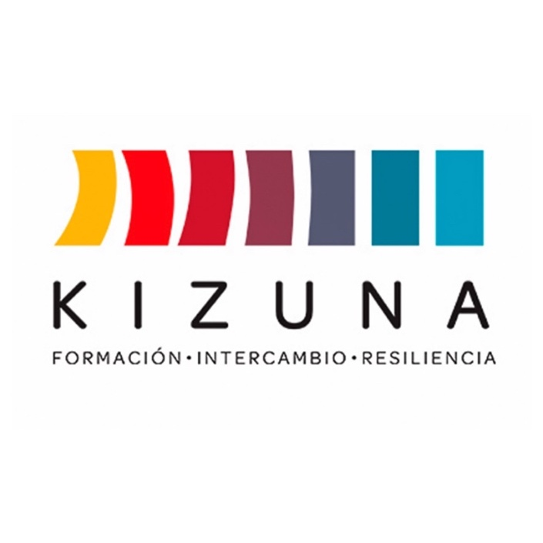

**FELLOWSHIP CALL**

**DIPLOMA COURSE ON TSUNAMIS:**

TSUNAMI ON THE COAST OF LATIN AMERICA AND THE CARIBBEAN: SCIENTIFIC BASES, HAZARD, AND VULNERABILITY.

**From November 3 to November 14, 2025**

Fellowship call available at https://www.agcid.gob.cl/.

Chilean International Cooperation Agency │ AGCID

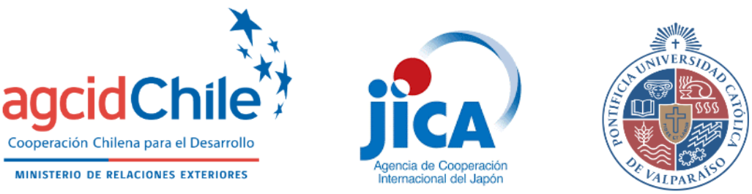

**BACKGROUND**

The diploma course on tsunamis of the Institute of Geography of the Pontifical Catholic University of Valparaiso (IG-PUCV), part of the “Building Resilient and Sustainable Societies for Disasters in Latin America and the Caribbean Project (KIZUNA II),” is designed to respond to the growing need for education and training of professionals in emergency management and tsunami warning systems. This demand has increased as a result of the devastating tsunamis that have occurred in recent decades, such as those in Sumatra-Andaman in 2004, Chile in 2010, and Japan in 2011.

Chile, one of the most seismically active countries in the world, has developed a solid experience in tsunami science and in improving its warning and preparedness systems. This experience has been reinforced by the occurrence of three destructive tsunamis on its coast during the last 14 years, which has boosted international collaboration and the specialization of national and international experts.

This tsunami diploma program is oriented to professionals from Latin American and Caribbean countries working in emergency management and tsunami warning systems. Given the increasing development and vulnerability of coastal areas in these countries, it is crucial to have trained personnel to minimize the effects of tsunamis through preparedness, warning, response and recovery.

The KIZUNA II project, led by the Chilean International Cooperation Agency (AGCID), the National Disaster Prevention and Response Service (SENAPRED), and the Japan International Cooperation Agency (JICA), has partnered with PUCV to offer this diploma course. During two weeks, participants will receive comprehensive training on earthquake and tsunami generation, the latest scientific advances, and hazard characterization. In addition, they will receive practical training in the National Tsunami Warning System (SNAM) of the Chilean Navy’s Hydrographic and Oceanographic Service (SHOA), ensuring that they acquire essential practical skills to face future emergencies.

**GENERAL INFORMATION**

1. **SUPERIOR GOAL**

Promote the strengthening of disaster risk governance and foster effective management in line with the principles established in the Sendai Framework and in accordance with the objective of the KIZUNA II Project, with the purpose of fostering the development of resilient societies in Latin American and Caribbean countries.

1. **OBJECTIVE OF THE DIPLOMA**

To provide theoretical and practical knowledge that will allow the reinforcement of tsunami risk reduction actions in their role as members of the tsunami warning systems of their respective countries. The course will address the phenomenon in a comprehensive manner, considering the scientific aspects, which will help them to improve their understanding of the hazard assessment, the social aspects involved, and the operational processes.

1. **RESULTS**

Through the diploma, students will acquire key competencies that will enable them to:

1. Reinforce knowledge on geophysical, seismological and oceanographic fundamentals of tsunamis.
2. Recognize national and international tsunami forecasting and early warning systems.
3. Review tsunami risk reduction actions in the participants' countries of origin.
4. Provide tools to assess risk and vulnerability to tsunamis.
5. To formulate an action plan according to the needs of the country and to apply it in the work institution, in the field of prevention and integrated post-disaster rehabilitation, with emphasis on DRR, based on the knowledge acquired.
6. **IMPLEMENTING INSTITUTION**

The Institute of Geography of the Pontifical Catholic University of Valparaiso[1] is dedicated to the creation, promotion and dissemination of knowledge in the field of geographic sciences, focusing on the study of territory and the interaction between society and the natural environment. This commitment is materialized through teaching, research, and outreach, with the aim of achieving high-quality standards and contributing to sustainable development both locally and globally.

1. **DURATION OF THE DIPLOMA**

The diploma will be held in a hybrid format for two weeks, between November 3 and 14, 2025. The academic activities will take place throughout the day, between 9:00 and 19:30 hours (UTC-3). The first week will consist of online academic activities, and the second week will consist of practical and on-site activities in Chile. In order to pass the diploma, the student must reach an attendance of more than 90% in the classes and 100% in the practical group and field activities.

1. **LANGUAGE**

The diploma course will be conducted entirely in Spanish.

1. **FELLOWSHIP BENEFITS**

The Kizuna II Program will assign a scholarship to the selected individuals, supporting their participation in the diploma course by financing[2] the following items:

* Tuition costs and program fees.
* Certificate of approval issued by PUCV.
* Round-trip airfare from the main international airport in the country of origin to the place where the course is held. Intermediate stopovers within the country of origin must be paid by the participant.
* Transfer airport-hotel-airport.
* Lodging in an establishment determined by the diploma course coordinators (references will be given to those selected with due notice).[3]
* Per diem in Chilean pesos, equivalent to 30 (thirty) US dollars per day for food, transportation and minor expenses.
* Health insurance.
* Transportation to field trips

1. **INVITED COUNTRIES AND/OR ORGANIZATIONS**

The governments of the following countries and regions are invited to nominate applicants for the diploma: Argentina, Brazil, Costa Rica, Colombia, Cuba, Dominican Republic, Ecuador, El Salvador, Guatemala, Honduras, Mexico, Panama, Peru, and Uruguay. Countries from the CARICOM community are also invited: Antigua and Barbuda, Bahamas, Barbados, Belize, Dominica, Grenada, Guyana, Haiti, Jamaica, Saint Lucia, Saint Kitts and Nevis, Saint Vincent and the Grenadines, Suriname and Trinidad and Tobago.

1. **TOTAL NUMBER OF PARTICIPANTS**

From twelve (12) to fifteen (15) participants[4].

1. **APPLICATION REQUIREMENTS**

The diploma is aimed primarily at people who meet the following requirements:

* Be a citizen and have residence in one of the invited countries. If temporarily residing in a country other than that of your citizenship, you must apply with the focal point of the country of which you are a citizen.
* Be nominated by your government in accordance with the procedures indicated in clause XI.
* Hold a university degree related to geosciences, natural sciences, environmental sciences, engineering, and/or natural resources.
* Professionals working in institutions relevant to disaster risk management.
* Have access to the Internet for at least 10 hours per day for the development of online classes (first week).

**Important note:**

* Individuals belonging to the **armed forces and/or national defense should refrain from applying** for the Kizuna II Project fellowship. In the case of applications from countries whose tsunami warning and monitoring system is under the primary responsibility of the armed forces, their members may be considered eligible by the Selection Committee, provided that institutional attribution and the commitment not to use the knowledge of the diploma for war purposes are accredited. The decision of the Selection Committee will be final.
* Those who have participated in any of the previous versions of the diploma course on tsunamis of the PUCV will not be considered in the present call.
* Priority in the selection process will be given to candidates who are working on projects related to the national development of their country.

1. **APPLICATION PROCESS**

Candidates must submit their application with the registration of all the requested information in digital format via e-mail (complete copy of their application including signatures and respective stamps) to the focal point of their country of origin (Annex VI) for the corresponding officialization. The documents to be submitted are the following:

* 1. Application form (Annex I) duly signed by the participant and his or her supervisor;
  2. Action plan proposal (Annex II);
  3. Letter of commitment (Annex III);
  4. Letter of institutional commitment (Annex IV)
  5. Letter of employment (Annex V)
  6. Certificate of professional title.
  7. Non-Spanish-speaking applicants must present proof of Spanish language proficiency, such as certification by an international exam, a copy of a university degree in case of having completed undergraduate or graduate studies in a Spanish-speaking country, or a letter of confirmation from the Chilean Embassy in the country.

Interested persons must submit their applications to the respective focal point in each country (see list of focal points in Annex VI) in order to make their application official. **Applications received without formalization by the focal point will not be considered at the time of selection.**

**Each focal point will determine the deadline date for the submission of applications; therefore, it is the responsibility of each applicant to consult directly with the focal point of the country to which they belong (Annex VI) for the respective closing date of the call for applications.** **These may vary from one country to another.**

The present call for applications for the tsunami diploma course will have the following stages and reference dates of application:

|  |  |
| --- | --- |
| **Stage** | **Date** |
| Closing of the call (for applicants, after confirmation with the focal point) | *August 22, 2025* |
| Officialization and pre-selection of candidates by the focal point through the AGCID Fellowships Platform (for focal point) | *August 29, 2025* |
| Selection Committee | *September 01 to 04, 2025* |
| Publication of results and notification of selected candidates | *September 5, 2025* |

The final date for receipt of applications by AGCID is August 29, 2025, and it may be closed prior to the date **indicated by the AGCID focal point in each country.** This must be confirmed in the country of origin of each applicant, according to the contacts in Annex VI.

**PLEASE NOTE:**

* No incomplete, illegible or late applications will be processed.
* Only applications officially submitted by the focal point will be evaluated. No applications submitted directly by the applicant will be considered.
* It is the applicant's responsibility to carefully read the call for applications with all its requirements, application procedures and all attached documents, as well as to submit the application in compliance with the professional requirements specified in each offer.

The information provided in the application form and its respective attachments is a sworn statement. Therefore, in the case of falsifying, adulterating, concealing or submitting inaccurate information in order to obtain the fellowship, the applicant will be subject to administrative, civil and criminal penalties in accordance with the regulations of his or her country of origin. Likewise, the applicant will be disqualified from applying for future scholarships indefinitely. This must be reported by the committee formed for the implementation of the scholarship.

1. **SELECTION**

The selection will be made by a technical committee between JICA, AGCID, and PUCV. This committee may evaluate the relevance of incorporating other experts in the field of natural disasters and/or public investment.

**The result of the selection will be published on September 5, 2025, on the AGCID website, available at www.agcid.gob.cl, for the information of all interested parties.**

The executors of the diploma will contact each selected candidate by e-mail to notify them, according to the contact information provided in the application form, and will directly coordinate all the arrangements for their participation.

Important: Only those who are selected will be notified, and once they have confirmed acceptance of the scholarship, they will be sent a guide with the corresponding instructions and procedures to follow.

**The final decision as to who will receive the scholarship is the sole decision of the Selection Committee and cannot be appealed.**

1. **PARTICIPANT'S OBLIGATIONS**

* Applicants are responsible for providing current contact information (Annex I: Application Form) and for periodically checking their e-mail accounts in case of requests and official notices from the coordinating team, according to the dates described in section XI.
* Participants will adhere strictly to the course program. Requests for changes or alterations to the initially established course program will not be accepted.
* Respect the indications given by the professors and ensure a good coexistence among the participants of the course.
* The course will be held in hybrid mode. The minimum attendance requirement for approval is 90% and 100% in the face-to-face phase in Chile.
* To carry out all the necessary procedures for their participation in the program, both online and in person, including obtaining the authorization from their supervisor and travel to Chile.
* Interruption of participation in the course will only be authorized in duly qualified cases that prevent the continuation of the training.

1. **DIPLOMA PROGRAM (PRELIMINARY)**

|  |  |  |  |  |
| --- | --- | --- | --- | --- |
| **Module** | **Date** | **General description** | **Activity format** | **Duration** |
| Online | Day 1:  Monday, November 03 | Welcome from the institutions (AGCID, JICA, SENAPRED, PUCV)  General concepts and knowledge level assessment (Dr. Marco Cisternas, PUCV) | Classes | 3 hours |
| Practical group work methodology and formation of groups for practical work | Practical activity | 1 hour |
| Seismological basis of tsunamis | Classes | 3 hours |
| Seismological characterization for the action plan | Practical activity | 1 hour |
| Day 2:  Tuesday, November 04 | Geophysical basis of tsunamis | Classes | 3 hours |
| Geophysical and geological characterization for the action plan | Practical activity | 1 hour |
| Oceanographic bases of tsunamis  Tsunami sources in Chile | Classes | 2 hours |
| Characterization of recent large Chilean tsunamis and lessons learned | Classes | 2 hours |
| Day 3:  Wednesday, November 05 | The seismic cycle in Chile: case studies | Classes | 3 hours |
| Characterization of recent large earthquakes in participating countries | Practical activity | 1 hour |
| Latest advances in understanding large earthquakes in Chile: Implications for current seismic risk | Classes | 3 hours |
| Characterization of tectonic coupling for the action plan | Practical activity | 1 hour |
| Day 4:  Thursday, November 06 | Mathematical modeling of tsunamis | Classes | 2 hours |
| Hazard, risk, and tsunami inundation maps | Classes | 1 hour |
| Application of inundation maps to define hazard | Practical activity | 1 hour |
| Tsunami evacuation potential on the coast of Chile: modeling, actual behavior, and optimization strategies | Classes | 2 hours |
| Hazards and vulnerabilities of coastal infrastructure | Classes | 2 hours |
| Day 5:  Friday, November 7 | Lessons from the 2011 Tohoku tsunami for both Japan and Latin America | Classes | 2 hours |
| The Tonga tsunami: new challenges for warning systems | Classes | 1 hour |
| Characterization of recent large earthquakes in participating countries | Practical activity | 1 hour |
| Use of historical and geological evidence to study past earthquakes and tsunamis  What can be expected in the seismic and tsunami future for central Chile? | Classes | 2 hours |
| Challenges for tsunami early warning systems: The cases of the 2018 Palu tsunami in Indonesia and the 2022 Tonga tsunami | Classes | 1 hour |
| Characterization of the Palu tsunami using social media videos | Practical activity | 1 hour |
| in person | Day 1:  Monday, November 10 | Evacuation drill in Viña del Mar | On-site (Viña del Mar) | 2.5 hours |
| Search for paleoseismic evidence of the 1730 tsunami | On-site (Quintero) | 6.5 hours |
| Day 2:  Tuesday, November 11 | Principles and scientific basis of the Integrated Tsunami Prediction and Warning System (SIPAT) | Classes | 2 hours |
| SNAM operational procedures | Classes | 2 hours |
| Tsunami drill in the SNAM room at SHOA | On-site (SHOA) | 4.5 hours |
| Day 3:  Wednesday, November 12 | Visit to the National Seismological Center (CSN). Lecture on “Phase W” at the Department of Geophysics, University of Chile. Visit to the National Disaster Prevention and Response Service (SENAPRED), Santiago | On-site (Santiago) | 10.5 hours |
| Day 4:  Thursday, November 13 | Guided study to prepare for specific knowledge test | Classes | 2.5 hours |
| Integrative workshop for the development of the action plan | Practical activity | 2 hours |
| Preparation of the action plan. Preparation of the document and oral presentation | Group work | 4.5 hours |
| Day 5:  Friday, November 14 | Submission of the report and oral presentations | Presentation | 4.5 hours |
| Specific knowledge test | Evaluation | 2.5 hours |
| Compliance survey. Discussion on the strengths and weaknesses of the program. Closing. | Closing activity | 1 hour |
| Total |  |  |  | Up to 85 hours |

**XV. CONTACTS**

**Pontifical Catholic University of Valparaiso**

General Directorate of International Affairs

Brasil 2950, Valparaiso, Chile.

+56 32 227 3541

ignacio.bahamonde@pucv.cl

Institute of Geography

Blanco 1733 Office C1

Valparaiso, Chile

+56 995420731

[marco.cisternas@pucv.cl](mailto:marco.cisternas@pucv.cl)

**Chilean International Development Agency (AGCID)**

Teatinos 180, 8th Floor.

Santiago, Chile

+56 22 827 5700

[agencia@agci.gob.cl](mailto:agencia@agci.gob.cl)

**KIZUNA II Project Coordination**

jica.kizuna2@gmail.com

1. For more information, see the institutional website at https://www.pucv.cl/.
2. No additional items to those mentioned below will be financed. Personal expenses must be covered by each participant.
3. No change of accommodation will be allowed, and personal expenses within the hotel will not be covered.
4. This academic program requires a minimum number of participants in order to be held and, for reasons of force majeure, may experience changes in its schedule, teaching staff, and/or method of delivery. Any change will be informed by the Course Coordination.