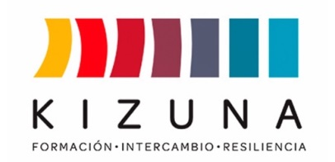

ANNEX IV

LETTER OF INSTITUTIONAL COMMITMENT
(To be signed by the direct supervisor)
DIPLOMA COURSE
“TSUNAMI ON THE COAST OF LATIN AMERICA AND THE CARIBBEAN: SCIENTIFIC BASES, HAZARD, AND VULNERABILITY”
(Kizuna II)

Hereby, on behalf of ________________________________________ (applicant's work institution), I commit myself to supporting Mr./Mrs. _______________________________________ (applicant's name) in the development of the initial idea of his/her proposed action plan (Annex II of this call), in case he/she is selected to participate in the diploma course “Tsunami on the Coast of Latin America and the Caribbean: Scientific Bases, Hazard, and Vulnerability," granting the following benefits after the training:
- Receive in our institution the action plan delivered by the selected participant once the diploma course has been completed.
- To guide the execution of the action plan proposed by the selected participant after the completion of the academic program, according to the interests, needs and possibilities of our institution and the country.
- To promote the realization of the action plan as part of the selected participant's work responsibilities, unless contingencies of our institution prevent it.
- Ensure the delivery of information on progress, achievements or non-achievements in the implementation of the action plan, which is subsequently required from Chile by AGCID, JICA or PUCV.

At _____________________________ (city, country), on _______________ (date).
SIGNATURE: _____________________________________________
NAME:
POSITION:
EMAIL:
**INCLUDE INSTITUTION'S STAMP**.

