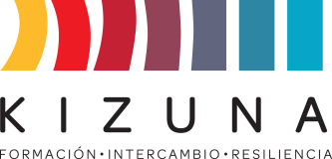

**ANNEX II**

**ACTION PLAN PROPOSAL**

A key outcome of the diploma course “Tsunami on the Coast of Latin America and the Caribbean: Scientific Bases, Hazard and Vulnerability” is the formulation and presentation by each participant of an action plan. This plan addresses tsunami awareness and the prevention and rehabilitation measures that could be taken in the participant's country of origin. The aim is to present it to their management and promote or implement it upon their return to their country.

The entities organizing the course, JICA, AGCID, and PUCV, will follow up on the development of the action plans.

This action, as an initial idea, **will be presented as an application requirement**.

Subsequently, during the diploma course, instructions, procedures, and basic scientific knowledge will be provided to complete the plan. As part of the course evaluation, the plan must be presented to the academics organizing the course, who will provide feedback and final suggestions.

**INSTRUCTIONS**

*Develop the following points in a Word or PDF document of no more than 5 pages, including text and tables.*

1. Participant name.
2. Country and city of residence.
3. Name of the institution where you work and your position.
4. Indicate the main policies in force in your country, as well as some programs, projects, and studies currently being developed in DRR and tsunami monitoring and forecasting systems.
5. Indicate the most relevant topics of the course for you.
6. Specify how the knowledge acquired in this course will improve your professional development in your country and what concrete actions you expect to take to achieve this.

|  |  |  |  |
| --- | --- | --- | --- |
| **OBJECTIVE** | **ACTIVITY** | **RESULT** | **TIME** |
|  |  |  |  |
|  |  |  |  |
|  |  |  |  |
|  |  |  |  |
|  |  |  |  |

1. Comments and/or suggestions.