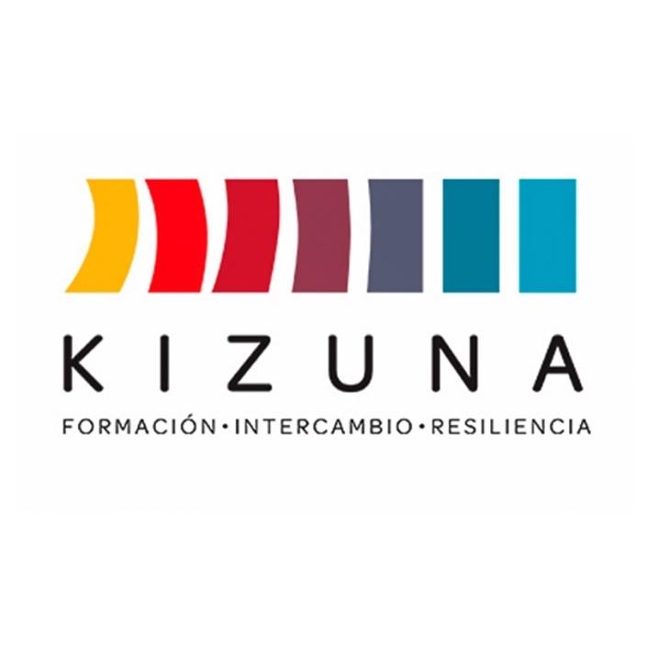

CALL FOR APPLICANTS

INTERNATIONAL COURSE
USE AND MODELING OF HISTORICAL DATA AND FUTURE PROJECTIONS UNDER CLIMATE CHANGE SCENARIOS

2° SEMI-PRESENTIAL EDITION

September 8 to October 10, 2025 (distance phase)
October 13 to 17, 2025 (in-person phase)
Valparaíso, Chile

Available at https://www.agcid.cl
Chilean Agency of International Cooperation for Development (AGCID)

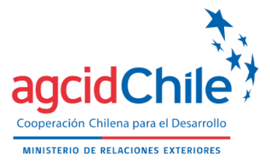 | 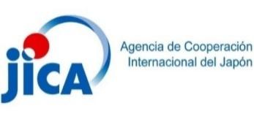 | 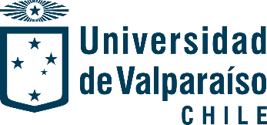 | 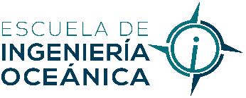

BACKGROUND
Climate change is one of the main threats to global sustainable development, particularly affecting coastal regions. These areas, which are home to more than 40% of the world’s population, face a set of interrelated risks, such as rising sea levels, intensified storms, coastal erosion and degradation of marine ecosystems. According to the Intergovernmental Panel on Climate Change (IPCC), sea levels could rise between 0.63 and 1.01 meters by the end of the 21st century under a high-emissions scenario, threatening millions of lives, critical infrastructure and economic activities that depend on coastal resources.
In Latin America and the Caribbean (LAC), this vulnerability can be exacerbated by factors such as unplanned urbanization, dependence on natural resources, and limited institutional capacity to address climate challenges. Projections indicate that by 2050, one-third of major coastal cities in the region could experience recurrent flooding due to the combination of extreme tides and intensified meteorological events. This scenario highlights the urgent need to strengthen technical and methodological capacities for adaptive planning and risk management in coastal systems.
The course “Use and Modeling of Historical Data and Future Projections Under Climate Change Scenarios” arises as a response to these needs, providing a platform for the training of professionals who can identify specific climate impacts on coastal systems and develop adaptation measures based on climate projections.
This course is developed within the framework of the "Project to Build Resilient and Sustainable Societies in the Face of Disasters in Latin America and the Caribbean (KIZUNA II)", carried out by the Government of Chile, through its Chilean Agency for International Development Cooperation (AGCID), in conjunction with the Japan International Cooperation Agency (JICA), inspired by the 2030 Agenda and its Sustainable Development Goals and the Sendai Framework for Disaster Risk Reduction, under which it is expected to contribute to the development and strengthening of the capacities of professionals and technicians in the regional space. The initiative corresponds to the second phase of the successful Kizuna Program that trained more than 5,000 participants in Chile during the years 2015 and 2020.
The course combines the analysis of meteorological and oceanographic variables with climate modelling techniques to project future scenarios that allow for the assessment of threats and the design of adaptation strategies. These tools are essential for the sustainability of coastal systems, especially in contexts where decisions must be based on scientific data and a comprehensive understanding of climate dynamics.
In this sense, the relevance of the course is framed in the need to develop technical capacities to face climate challenges in an effective and coordinated manner. By empowering key actors with knowledge and tools to identify threats, assess vulnerabilities and formulate adaptive responses, this program directly contributes to strengthening coastal societies in the LAC region, promoting their sustainability in the face of the effects of climate change.

GENERAL INFORMATION

SUPERIOR GOAL
Promote policies, strategies, programs and collaborative actions with Latin American and Caribbean (LAC) countries in accordance with the action priorities of the Sendai Framework for Disaster Risk Reduction 2015 - 2030 and the Sustainable Development Goals (SDG 2030).

COURSE OBJECTIVES
Strengthen the capacities of coastal cities, especially through the marine and ocean projections working groups of Latin America and the Caribbean (LAC), to identify impacts and adaptation measures in the face of climate change scenarios, using climate change projections.

EXPECTED RESULTS
Course participants are expected to improve their knowledge and skills in:

- Describe the relationship of change in the average values of environmental variables with the impact of human settlements.
- To understand the variables that produce impacts on coastal zones in a climate change scenario.
- Identify the different sources of climate information for the projection of meteoceanographic variables to estimate impacts in the face of climate change scenarios.
- Recognize climate projection models, differentiating between the different scales, as an input for the preparation of adaptation plans for climate change scenarios.
- Apply a methodology for processing climate projection data as an input for the preparation of adaptation plans for climate change scenarios.
- Develop an adaptation plan for the sustainability of coastal systems in the face of climate change scenarios.
- Formulate an Action Plan according to the needs of the country, to be applied in the working institution, within the scope of Marine and Ocean Projections Working Groups (MOPWG) of LAC, with emphasis on disaster risk reduction and climate resilience, based on the knowledge acquired.

IMPLEMENTING INSTITUTION
The course will be implemented by the School of Oceanic Engineering , of the Faculty of Engineering of the University of Valparaiso² .
The school’s mission is to train professionals of excellence at the undergraduate, graduate and postgraduate levels; to develop applied research, technical assistance and linkage with the environment, in the areas of maritime, coastal and port engineering, contributing to the development of the country's maritime interests with ethical-professional, social and environmental responsibility. It has more than 20 years of experience, highlighting the participation in the first version of the KIZUNA project.

COURSE DURATION
This course will be taught in blended mode, separated into a first distance learning phase and a second face-to-face phase.
The first stage of distance learning will be implemented between September 8 and October 10, 2025. It considers the realization of synchronous activities, with direct contact with the academic staff through a videoconference platform, and asynchronous activities, where each student will be able to advance at his own pace with the support of material specially prepared for his autonomous progress, enabled in a virtual classroom platform "Moodle".
Regarding synchronous activities, a 1.5-hour lecture will be held each week, in which elements of the different units of each module will be addressed.
Regarding asynchronous activities:

- Video capsules, between 15 and 30 minutes long, will be used to present concepts that will later be reviewed in the synchronous session, where any remaining doubts can be resolved;
- A selection of texts will be assigned for each student's personal review, oriented to facilitate the understanding of the contents and the achievement of the objectives;
- discussion forum activities are incorporated, so that each student must apply the concepts seen during the week;
- A questionnaire activity is incorporated at the end of each week for content evaluation, which has an eminently formative purpose

The second stage, face-to-face, will take place from Monday, October 13 to Friday, October 17, completing 6 hours of workshop-type work in Valparaíso, Chile, as well as a field trip to the coastal area of the region.

Web site: http://ingenieriaoceanica.uv.cl
² Web site: http://www.uv.cl
The course considers the following curriculum:
Module | Virtual | On-site | Grand Total
1. Climate change and its impact on coastal systems. | 6 | 6 | 12
2. Climate projection models. | 9 | 6 | 15
3. Fundamentals of climate projection processing. | 9 | 6 | 15
4. Adaptation to climate change scenarios. | 6 | 12 | 18
Total de horas: | 30 | 30 | 60
*The Curriculum presented is subject to minor variations, which do not alter the general objective of the international course.

LANGUAGE
The course will be taught entirely in Spanish.

SCOLARSHIP BENEFITS
Those selected will receive a scholarship that will cover 100% of the following items:

- Tuition and fees for the academic program.
- Certificate of approval.
- Round-trip airfare from the main international airport of the country of origin to Santiago de Chile (intermediate stopovers within the country of origin must be paid by the participant).
- Transfer in Chile airport-hotel-airport.
- Accommodation with breakfast at the hotel to be determined by the course organization, both in Santiago and Valparaíso (references will be given to those selected with due notice) ³
- Per diem of USD 30.- (thirty U.S. dollars) per day, in Chilean pesos at the exchange rate established by JICA, for food, transportation in the city and minor expenses.
- Health insurance. Excludes pre-existing conditions or pregnancy, similar coverage Assist Card ACR35.
- Transportation on field trips.

3 No change of accommodation will be allowed and no personal expenses within the hotel will be covered.

INVITED COUNTRIES
The governments of the following countries and regions are invited to nominate applicants for the Course: Argentina, Bolivia, Brazil, Colombia, Costa Rica, Cuba, Dominican Republic, Ecuador, El Salvador, Guatemala, Honduras, Mexico, Panama, Paraguay, Peru and Uruguay, and the following CARICOM Member States: Antigua and Barbuda, Bahamas, Barbados, Belize, Dominica, Grenada, Guyana, Haiti, Jamaica, Saint Lucia, Saint Kitts and Nevis, Saint Vincent and the Grenadines, Suriname and Trinidad and Tobago

TOTAL NUMBER OF PARTICIPANTS
The number of participants from invited countries will not exceed 18 in total⁴ , and there are no pre-established quotas per country.

APPLICATION REQUIREMENTS
This International Course is aimed at people who meet the following application requirements:

- Be a citizen of the country called and have residence in one of these countries. In case of being temporarily in a country other than that of his/her citizenship, he/she must apply with the AGCID focal point of the country of which he/she is a citizen.
- Be nominated by his/her government in accordance with paragraph XI.
- Not belong to the Armed Forces and/or National Defense;
- Hold a university degree related to science, engineering sciences, oceanography, environmental sciences and other related disciplines.
- Possess work experience related to the analysis, formulation and/or evaluation of public investment projects, development of guidelines or methodologies for the formulation of public infrastructure projects, investment planning, estimation of civil works budget, in charge of identifying land for the development of social housing or public infrastructure projects.
- Have an advanced level or equivalent of spoken and written Spanish;
- To have access to the internet, to have full authorization from his/her institution, and to have total predisposition and availability of time to participate in the classes and online sessions at the established schedule, taking into consideration the time differences between countries. Also, to have the authorization to participate in the face-to-face phase in Chile, in case of being selected.

Important note: Priority in the selection process will be given to candidates who are working on projects related to the national development of their country.

4 This academic program requires a minimum number of participants in order to be held and, for reasons of force majeure, may experience changes in its schedule, teaching team and/or method of delivery. Any change will be informed by the Project Coordination.

APPLICATION PROCESS
Candidates must submit their application via e-mail to the AGCID Focal Point in their country of origin (Annex VI), with a record of all the information requested in digital format (full copy of their application including signatures and respective stamps). The documents to be submitted are the following:
- Application Form (Annex I) duly signed by the participant and his/her employer.
- Letter of Commitment (Annex II);
- Proposed Action Plan (Annex III);
- Labor Certificate (Annex IV)
- Certificate of Institutional Commitment (Annex V)
- Certificate of Professional Degree
- Non-Spanish speaking applicants must present proof of language proficiency such as: certification by international exam, copy of university degree in case of having completed undergraduate or graduate studies in a Spanish-speaking country, letter of confirmation from the Chilean Embassy in the country.

Interested applicants must submit their applications to the respective AGCID Focal Point in each country (see list of focal points in Annex VI), in order to formalize their application. Applications received without the official approval of the AGCID Focal Point will not be considered at the time of selection.
Each Focal Point will determine the deadline for the submission of applications, therefore, it is the responsibility of each applicant to consult directly with the AGCID Focal Point of the country to which he/she belongs for the respective closing date. These may vary from one country to another.
This call for applications for the International Course will have the following stages and reference dates:
Stage | Dates
Closure of the call (for applicants, after confirmation with the AGCID Focal Point) | August 08, 2025
Pre-selection of candidates and entry of application to the AGCID Scholarship Platform (for Focal Point) | August 15, 2025
Selection Committee | August 18 -21, 2025
Publication of results and notification of selected candidates | August 22, 2025
The final date for receipt of applications by AGCID is August 15, 2025, and may be closed prior to the date indicated by the AGCID Focal Point in each country. This must be confirmed in the country of origin of each applicant, according to the contacts in Annex VI.
TO CONSIDER:
- Incomplete, illegible or late applications will not be processed.
- Only applications officially submitted to Chile by the AGCID Focal Point will be evaluated. Any application submitted directly by the applicant will not be considered.
- It is the applicant's responsibility to carefully read the call for applications with all its requirements, application procedures and all attached documents, as well as to submit his/her application in compliance with the professional requirements specified in each offer.
The information provided in the application form and its respective annexes is a sworn statement. Therefore, in the case of having falsified, adulterated, concealed or submitted inaccurate information in order to obtain the scholarship, the applicant will be subject to the respective administrative, civil and criminal penalties, in accordance with the regulations of his/her country of origin. Likewise, the applicant will be disqualified from applying for future scholarships indefinitely. This must be reported by the committee formed for the implementation of the scholarship.

SELECTION
The selection will be made in Santiago, Chile by a Technical Committee between JICA, AGCID and the University of Valparaiso. This Committee may also evaluate the relevance of incorporating other experts in the field of natural disasters and/or public investment.
The results of the selection process will be published on August 22, 2025, on the AGCID website, available at www.agcid.gob.cl, for the information of all interested parties.
The Course executors will contact each selected candidate by e-mail to notify him/her, according to the contact information provided in the Application Form and will directly coordinate all the arrangements for his/her participation.
Important: Only those who are selected will be notified and, once they have confirmed their acceptance of the scholarship, they will be sent a guide with the corresponding instructions and procedures to follow.
The final decision as to who will receive the scholarship is the sole decision of the Selection Committee and its decision is final.

REGULATIONS
Participants must respect the following rules:

- Applicants are responsible for providing current contact information (Annex I: Application Form) and for periodically checking their e-mail accounts in case of requests and official notices from the coordinating team, according to the dates described in paragraph XI.
- Participants will adhere strictly to the course program. Requests for changes or alterations to the initially established course program will not be accepted.
- Respect the indications given by the Instructors and ensure a good coexistence among the trainees of the Course.
- To participate with dedication in the initial stage of classes and sessions in synchronous mode, according to the program mentioned in paragraph XVI. For the approval of the Course, in addition to the evaluations, a minimum attendance of 80% of the synchronous sessions in the distance phase and 100% in the face-to-face phase will be required. Likewise, 100% of the asynchronous activities assigned during the distance phase must be completed.
- Airline tickets will be limited to the dates and location of the course. No changes in dates or itinerary will be made for personal reasons.
- Carry out all the necessary formalities for their participation in the course, including obtaining authorization from their employer, visa processing and others.
- Interruption of participation in the Course will only be authorized in duly qualified cases that prevent the continuation of the training.

COUNTRY PRESENTATION
As part of the course activities, during the face-to-face phase in Chile, participants must make a brief presentation describing the situation of their country's national risk management organization, with a focus on coastal risks.
In the case of more than one participant per country, the presentation may be made in a group divided among them, but in the same time as established.

GENERAL COURSE PROGRAM (PRELIMINARY)
The following preliminary program is considered:
Week |  | Module and Unit
1 |  | Climate change and its impact on coastal systems.
 |  | 01. Introduction to climate change in coastal systems and the physics of meteoceanographic phenomena.
 |  | 02. Responses to the impact of climate change on coastal systems.
2 |  | Climate projection models.
 |  | 03. Methodological approach in the use of meteoceanographic variables with climate information sources.
 |  | 04. Climate projections of wind, atmospheric pressure, waves, meteorological tide and sea level.
 |  | 05. Climate projection models
3 |  | Climate projection models.
 |  | 04. Climate projections of wind, atmospheric pressure, waves, meteorological tide and sea level.
 |  | 05. Climate projection models
 |  | Fundamentals of climate projection processing.
 |  | 06. Impacts on coastal areas
4 |  | Fundamentals of climate projection processing.
 |  | 07. Processing and visualization of climate projections
5 |  | Adaptation to climate change scenarios.
 |  | 08. Experiences in adaptation measures in coves, ports, coastal infrastructure, settlements, beaches, wetlands and islands.
 |  | 10. Adaptation planning for climate change scenarios.
Start of Presential Phase (the days within this week are indicated)
6-1 | Climate change and its impact on coastal systems.
 | 01. Introduction to climate change in coastal systems and the physics of meteoceanographic phenomena.
 | 02. Responses to the impact of climate change on coastal systems.
6-2 | Climate projection models.
 | 03. Methodological approach in the use of meteoceanographic variables with climate information sources.
 | 04. Climate projections of wind, atmospheric pressure, waves, meteorological tide and sea level.
 | 05. Climate projection models
6-3 | Fundamentals of climate projection processing.
 | 06. Impacts on coastal areas
 | 07. Processing and visualization of climate projections
6-4 | Adaptation to climate change scenarios.
 | 08. Experiences in adaptation measures in coves, ports, coastal infrastructure, settlements, beaches, wetlands and islands.
 | 09. Exposure and impact analysis in coastal areas.
 | 10. Adaptation planning for climate change scenarios.
6-5 | Adaptation to climate change scenarios.
 | 10. Adaptation planning for climate change scenarios.

CONTACTS
University of Valparaíso
Felipe Caselli Benavente.
Av. Brasil 1786
Valparaíso, Chile
Phone: +56 32 299 5916
Email: ingenieria.oceanica@uv.cl

Chilean Agency of International Cooperation for Development (AGCID)
Teatinos 180, Piso 8.
Santiago, Chile
Phone: +56 22 827 5700
Email: agencia@agcid.gob.cl

KIZUNA II Project Coordination
Email: jica.kizuna2@gmail.com

